**CHAPTER 6**

**SNAPSHOTS**

This Figure Represent the Smart Village Associated with the Eco-Friendly Environment. Also this figure shows us about proper plantation of Trees and plantation of Windmill Producing a good Quality of Renewable Resource’s.

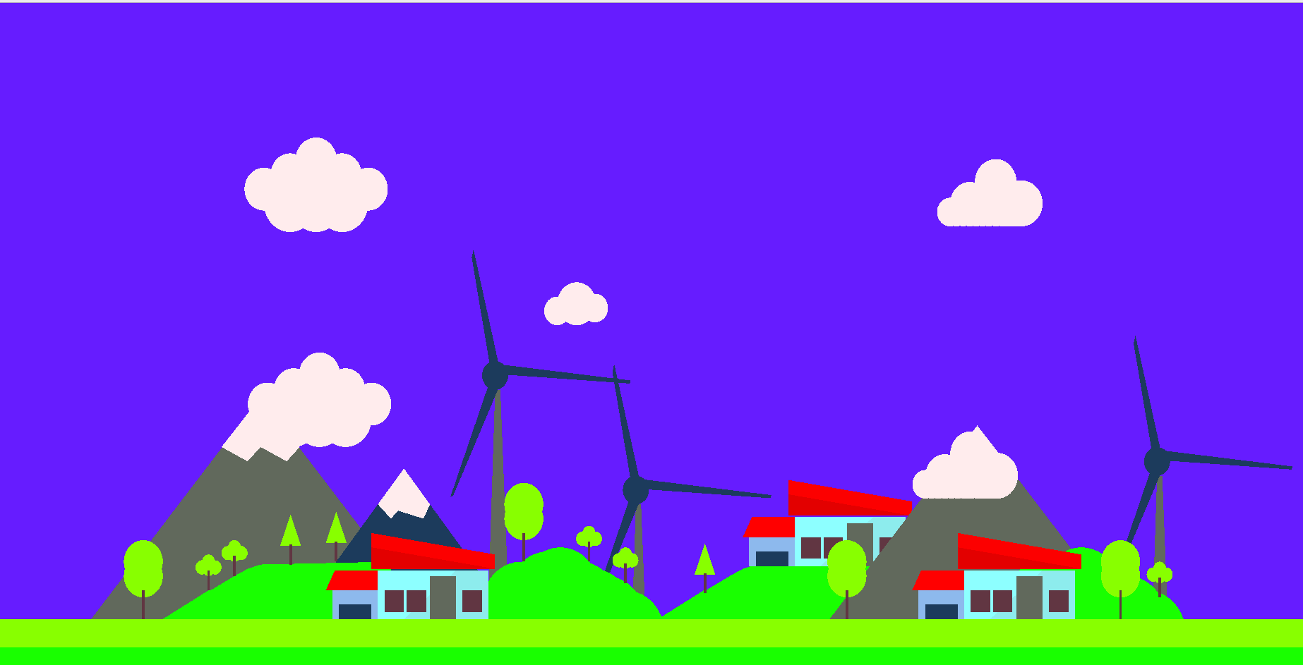

Fig:6.0 Smart Village With OpenGL